# Ideation Phase Empathize & Discover

|  |  |
| --- | --- |
| Date | 31 October 2022 |
| Team ID | PNT2022TMID33575 |
| Project Name | Project - Natural Disaster Intensity Analysis and Classification Using Artificial Intelligence |
| Maximum Marks | 4 Marks |

**Empathy Map Canvas:**

An Empathy map is a collaborative tool teams can use to gain a deeper insight into their team members. Mush like a user personal, an empathy map can represent a group of users ,such as a customer segment .

The empathy map was originally created by Dave gray and has gained much popularity within the agile community.

Creating an effective solution requires understanding the true problem and the person who is experiencing it. The exercise of creating the map helps participants consider things from the user’s perspective along with his or her goals and challenges.

**Example:**

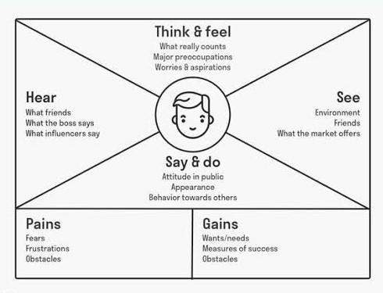

# Empathy Map Canvas for Natural Disaster Intensity Analysis and Classification Using ArtificialIntelligence

**Reference**: <https://tinyurl.com/ibmempathymap>

